Unit 5 Review

1. $\overline{DE}$ is a midsegment of $∆ABC$.

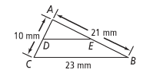

In millimeters, what is DE?

1. Find the value of x.

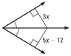

1. Put the angles in order from least to greatest.

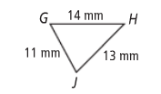

1. Draw an angle bisector, perpendicular bisector, median and an altitude in a triangle.
2. In the figure below, $∆ABC$ has vertices A(-3, -5), B(-4, 3), and C(4, 1). D is the midpoint of $\overline{AB}$, E is the midpoint of $\overline{BC}$, and F is the midpoint of $\overline{AC}$.

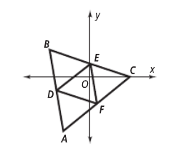

What are the coordinates of the vertices of $∆DEF$?

1. A surveyor took some measurements across a river, as shown below. In the diagram, AC = DF and AB = DE.

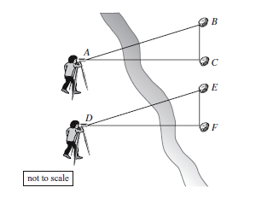

The surveyor determined that $m∠BAC={29}^{0}$ and $m∠EDF={32}^{0}$. What can you conclude about BC compared to EF?

1. How long is $\overline{EF}$?

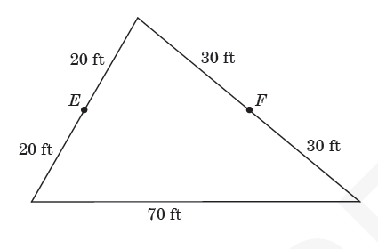

1. Rebecca is designing a backpack and needs to determine the length of the adjustable strap that connects the shoulder strap to the backpack. The height of the backpack is 20.5 inches, and the shoulder strap is 14 inches. What is the range that the adjustable strap could be?

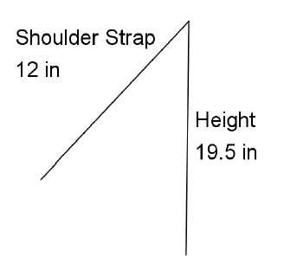

1. What is the perimeter of $∆ABC$ if D is the midpoint of $\overline{AB}$, E is the midpoint of $\overline{BC}$, and F is the midpoint of $\overline{AC}$?

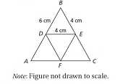

1. For the triangle, find the coordinates of the point of concurrency of the perpendicular bisector of the sides.



1. What is the measure of the interior angle of a nonagon?
2. Determine the length of x in the figure below.

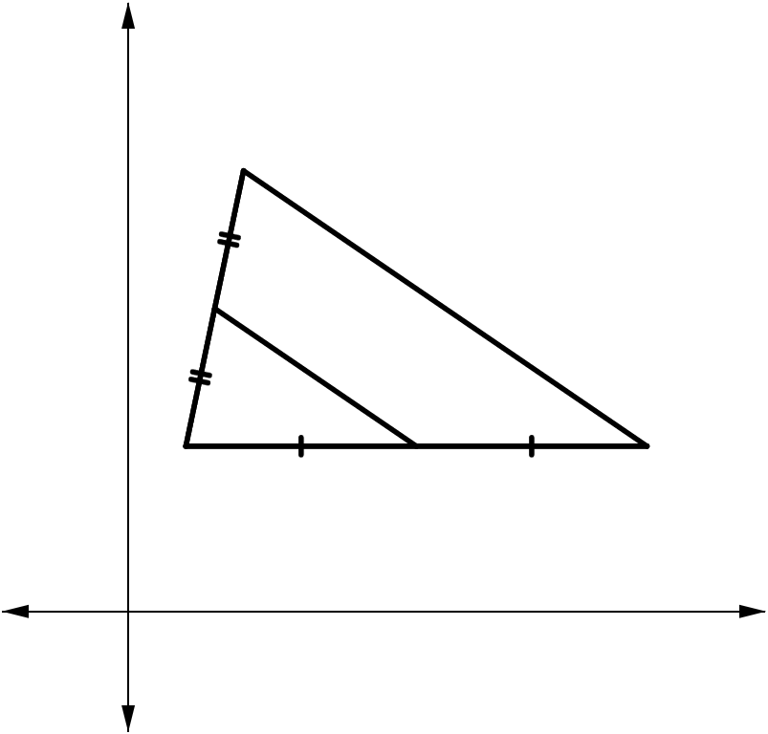

$$x ft.$$

$$\frac{124}{3} ft.$$

1. Determine the range of possible values of $x$.

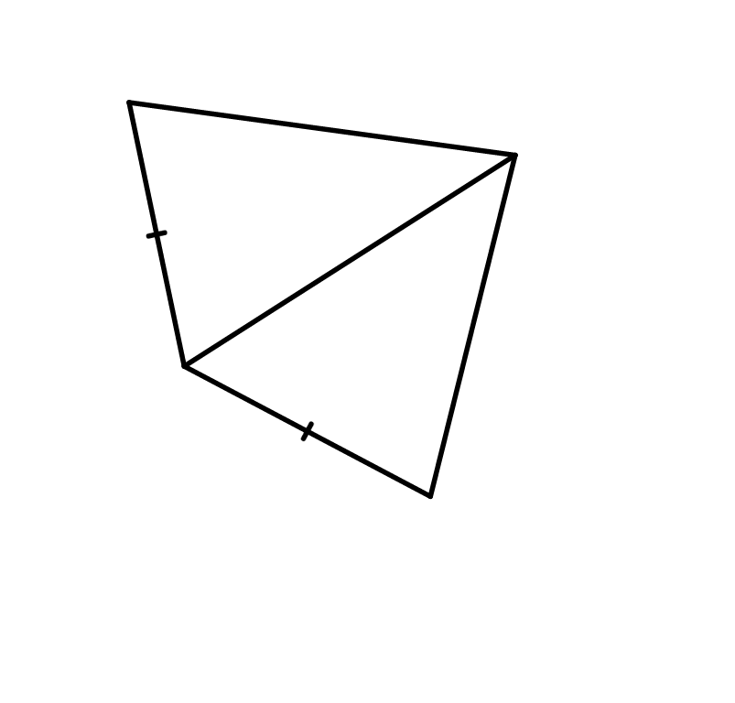

$$A$$

$$6.33$$

$$7.1$$

$$M$$

$$82°$$

$$H$$

$$\left(3x-32\right)°$$

$$Y$$