Review Unit 1 Test
Study both quizzes.
- Definitions
- Name planes
- Name rays
- Name opposite rays
- Name angles
- Use Segment Addition Postulate
- Midpoint to find measures
- Bisector to find measures
- Midpoint formula
- Distance formula to find perimeter
- Constructions
- Parallel and Perpendicular lines
- Writing equations of parallel and perpendicular lines
- Identifying parallel and perpendicular slopes
Problems to practice:
- If AC = 40, then find the value of x and then find AB & BC.
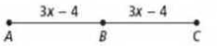

- Find the perimeter of $∆AFE$
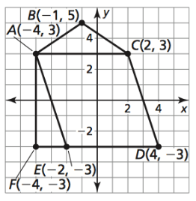
- Find HG.
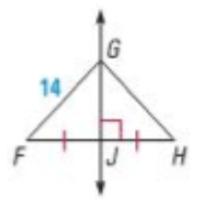
18

- Write the equation of a line passing through (-3, 8) and is perpendicular to x + 4y = 10.

- Two students were paired up working on determining which lines were parallel, perpendicular, or neither. Here are the two equations.
y = 3x - 4 and x + 3y = 6.

Janus worked out the two equations and found them to be perpendicular, and Karen determines them to be neither. Who is correct? Support your answer by showing your work.

