Congruent Triangle Project
Due Date: 12/2/2019
Overview: Students in geometry are expected to understand the rules of triangle congruence – whether using Side-Side-Side, Side-Angle-Side, or other ways to identify triangles that are identical. For this project, students will construct a popsicle-stick truss bridge made up of mostly congruent triangles (see attached examples). Triangles may be overlapping to provide the structural support necessary to make a solid bridge. After constructing a truss bridge out of popsicle-sticks, students will then need to identify the various types of triangles used by color-coding them with paint, markers, etc. Obviously the deck of the bridge will be a flat and solid surface, so it is mainly the sides of the bridge that will showcase use of congruent triangles. Completing this project will also require students to make a “key” that easily identify types of triangles used. The students must also create a background for the bridge to be up against. It can only be made up of triangles of different types. No other shapes can be used, if you want other shapes, then it must be made out of triangles. There are examples of artwork with triangles as well as the bridges.
Supplies: Students will be given popsicle sticks, glue, paper, colored pencils, markers, crayons, straight edge and protractor. Glue sticks work better but that would have to be done at home.
Direction for Bridge:
Step 1:  Make a plan for the type of truss bridge you would like to create. Use the attached bridge designs or research your own. Other structures like gazebos, Eifel Tower, etc. may also be replicated as long as it consists of only triangles | Step 2:  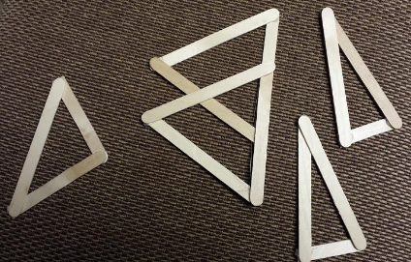  Begin creating congruent triangles with your popsicle-sticks. Popsicle-sticks can easily be cut with scissors to make different lengths. | Step 3:  Assemble triangles into your structure using your plan as your guide.  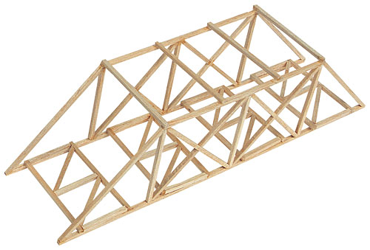
Step 4:  Color-code your triangles by coloring with markers or paint.  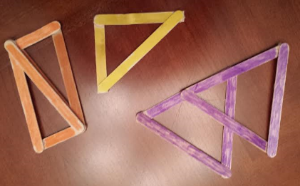 | Step 5:  Make the deck of your truss bridge solid by creating a flat surface of popsicle-sticks glued tightly together. | Step 6:  Create a “key” to submit with your finished structure identifying types of congruent triangles with postulates SSS, SAS, etc and with lengths and angle measurements. Example: ALL PURPLE TRIANGLES ARE EQUALATERAL EQUIANGULAR WITH 60° ANGLES AND 4.5 INCH SIDE LENGTHS. ETC.

Direction for artwork: You will be creating a piece of artwork using triangles and triangles only. NO other shapes are permitted in your project. If you want any other shapes, you must make them out of triangles. Be creative and colorful in your design using crayons or colored pencils only (no markers).
Your design must include the following: • acute triangles • obtuse triangles • right triangles • scalene triangles • equilateral/equiangular triangles • isosceles triangles • congruent triangles that can be proven by using SSS, SAS, ASA, and AAS
You may use as little or as many of the above mentioned triangles in your artwork; however, they must be used at least once and the entire paper needs to be covered. No white of the paper should be exposed and 90% of the paper needs to be covered in triangles. You MUST us a ruler!!! Do not free hand the triangles.

** Use your imagination and have fun with this project. ** No late projects will be accepted. Use your time wisely in class. This project can be completed at home and will be due the day you return. This is a TEST grade.

Artwork rubric
100 75 50 0
30% based on classification of triangles | All triangles are used in the artwork and represented correctly. | 1-2 triangles are missing from the artwork | 3-4 are missing from the artwork | 4 or more triangles are missing from the artwork
30% based on properties of triangles | All four postulates of congruent triangles are evident in artwork (SSS, SAS, ASA, AAS) and are represented correctly. | One postulate of congruent triangles is missing (SSS, SAS, ASA, AAS) | Two postulates of congruent triangles are missing (SSS, SAS, ASA, AAS) | Three or more of the postulates of congruent triangles are not represented in the artwork.
10% based the percentage of triangles used in artwork | Entire paper is covered with 90% representing triangles | Minimal white of paper is exposed and/or is mostly covered with triangles. | 50% or more of white is exposed on the paper and/or is minimally covered in triangles. | More than 50% of white is exposed on paper and/or very few triangles are used.
10% based on neatness | Project is neat and clearly thought out and planned. Project incorporates a wide variety of colors. |  |  | Project was rushed, messy, and not taken seriously. Few or no color was used in the project
20% based on proper tools used | Project is completed using a straight edge on all lines. | Project is completed using a straight edge on more than ½ of the lines. | Project is completed using a straight edge on less than ½ of the lines. | Project is completed without a straight edge.
Total:

Bridge Grading:
Grading will be based on the following criteria - neatness, creativity, structural stability, having a key that correctly identifies congruent triangles within your structure, and having multiple types of congruent triangles within your structure. An A+ project will be solid, colorful, have various sizes and shapes of congruent triangles and have a key that identifies those various congruent triangles within the structure.

Various examples of truss bridge designs below:

